KP97 -

Functionality
Cost center planning forms part of the overall business planning process. Cost center planning involves entering plan figures for costs, activities etc. for a particular cost center and a particular planning period. We can copy previous year’s plan figure to next year plan.

Scenario
During the annual planning process the last year’s plan figures can be copied to the next years plan. As well as expediting the process, the copied plan values can then be used as a basis to develop a new plan.

Requirements
A plan must exist as a source on a plan version.

Menu Path | Accounting → Controlling → Cost Center Accounting → Cost Center Accounting → Planning → Planning Aids → Copy → KP97 - Copy Plan to Plan
Transaction Code | KP97

1. Double Click on KP97 - Copy Plan to Plan

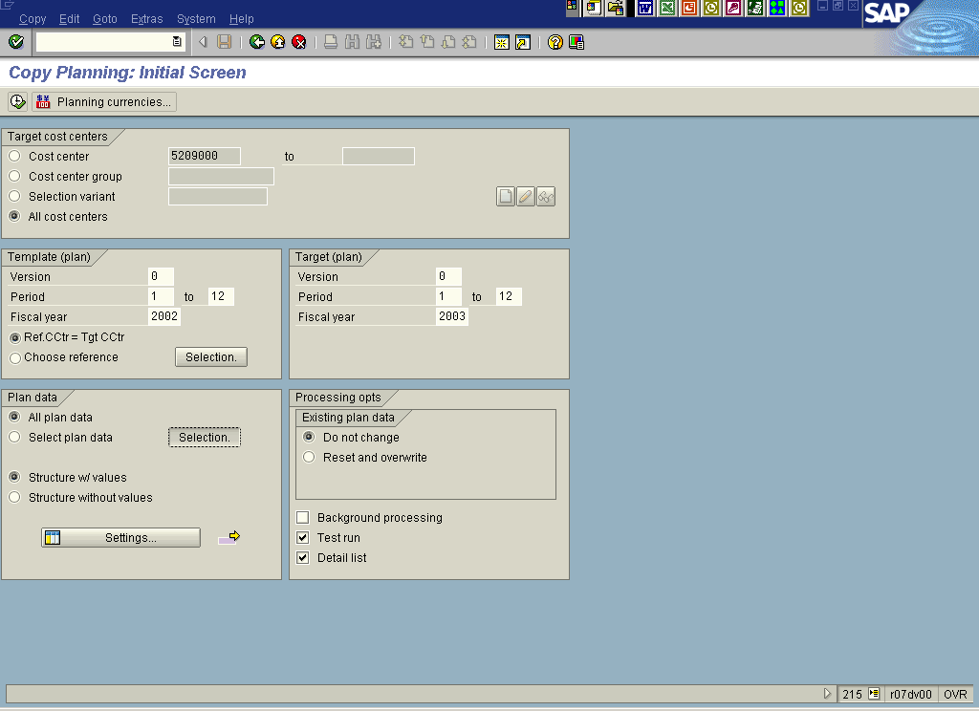

2. Click <radio button> All cost centers .
3. Update the following fields:

Field Name | Description | Values
Template (plan) From Period | Template from period | Example: 1
Template (plan) To Period | Template to period | Example: 12
Template (plan) Fiscal Year | Template Fiscal Year | Example: 2002
Target (plan) Version | Plan Version | Example: 0
Target (plan) From Period | Target from period | Example: 1
Target (plan) To Period | Target to period | Example: 12
Target (plan) Fiscal Year | Target Fiscal Year | Example: 2003
4. Click Selection. Button .

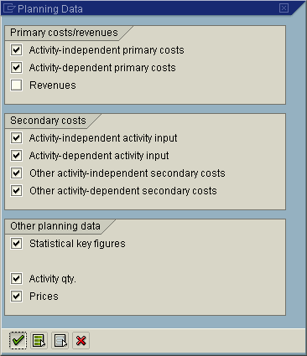
5. Click on the Select All button.
6. De-activate <radio button> Revenues.
7. Click Enter .

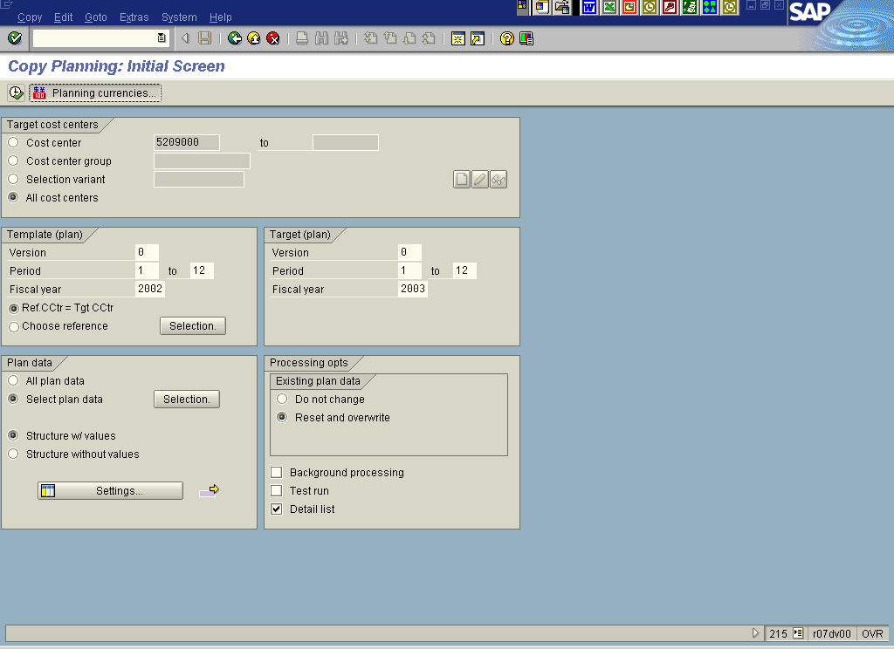

8. Click <radio button> Reset and overwrite .
9. Click <checkbox> Test run to run the process in productive mode.
10. Click Planning currencies... Button .

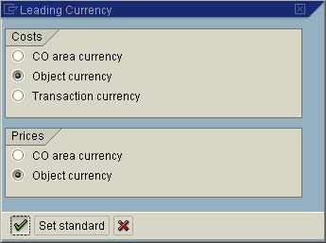

11. Click <radio button> Object currency .
12. Click the Enter button.

Warning

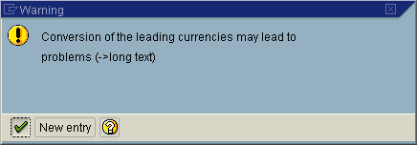

Note: You are copying costs with the object currency as leading currency. You should check that all objects in the target version use the same object currency as the corresponding object in the source version.

13. Click the Enter button.

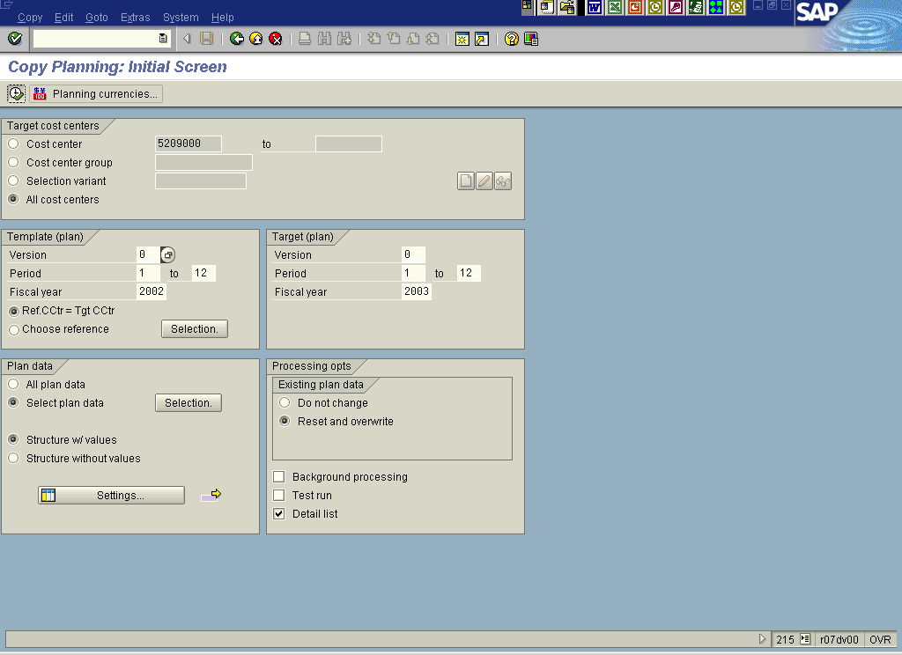
14. Click Execute



15. Click Yes Button .

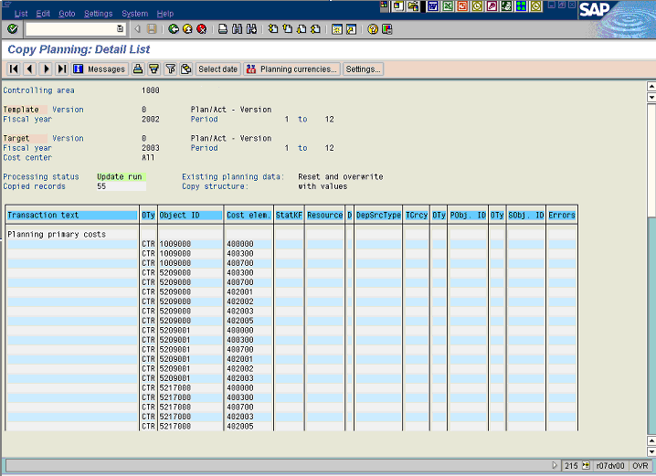

16. A list of copied plan values is displayed.

